SCIENCE SAFETY SCAVENGER HUNT

Directions: Work as an individual or in pairs, but complete your own sheet. Write your answers and map the room on another piece of paper. As you answer the questions, label the safety features in your room. Use the Internet if you do not know an answer.
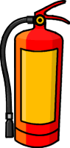
- Find the fire extinguisher and label on your map.
- What kind is it (A,B,C, or D or ABC)?
- Would you use this to put out a small paper fire on the top of your lab table? If not, what would you use?
- Describe how you would activate the extinguisher to put out a fire.
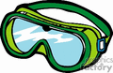
2. Find the cabinet containing the safety glasses and label. If you wear
prescription glasses or contacts, do you still need to wear glasses/goggles
during a lab? Should you use safety goggles when boiling water, even if
there are no chemicals involved? Why or why not?

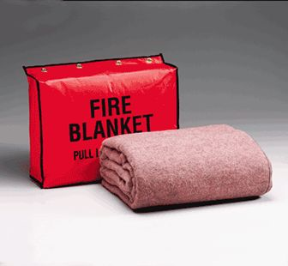
- Where is the fire blanket? Label.
- How do you get it out?
- What color is it?
- Would you use this to put out small fires at your table? If not, what would you do?
- Would you use this if you spilled acid on your clothes? If not, what would you do?
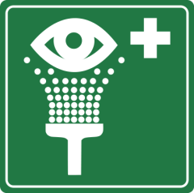
- Would you use this if someone’s clothes were on fire? If not, what would you do?
- What would you do if your clothes caught fire?

- Locate and label the eye wash station. You may test it, but be aware that it drains near your feet! How long should someone wash their eyes if they were splashed with a chemical?

- Locate and label the safety shower. DO NOT TEST IT! Due to the amount of water produced, your teacher will demonstrate this one for you later. Name two situations that might call for the safety shower to be used.

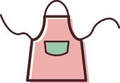
- Find the fume hood and label.
- What is the purpose of the fume hood?
- What types of chemicals should be heated or used in it?

- Find and label the location of lab aprons.
(a) Why do you wear an apron?
(b) When should you remove your glasses/goggles and apron?

- Locate and label all sinks.
  - When finished with the contents of a test tube or beaker, do you dispose of the residual by dumping it in the sink and rinsing with water? If not, what should you do?
  - When finished with a lab, do you rinse all glassware and leave it in the sink?
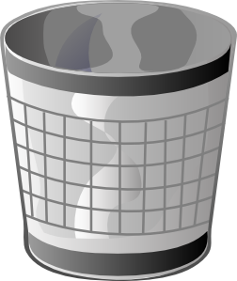

- Locate and label the paper towels and garbage bins.
  - What should you do if you notice that the beaker you are using in lab
has a crack in it?
  - Why should you alert the teacher to clean up chemical spills? What
other dangers could a chemical spill cause?

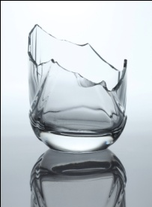
- Locate and label the broken glass container.
(a) What should you do if you break a test tube during a lab activity?
(b) Why should you not put the broken glass into the garbage bin?

- Locate and label the emergency button in the room. This button shuts off power and gas to your room. NOTE: This can only be used by the teacher!
- Think of one reason why your teacher may have to push this button.

- The two most common mishaps in lab are minor cuts and burns. Locate and label the first aid kit. Be sure to inform the instructor if and when you have a mishap.
  - What is the first thing you do when you get a minor burn? Why?
  - What is the first thing you do when you get a minor cut? Why?
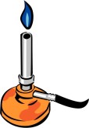
13. Locate the gas jets at the lab tables. Bunsen burners are connected to these
fuel sources to create an “open flame.” A hot plate can be used for heating
as well, but it is NOT an open flame device.
- When the turning lever is parallel to the nozzle, is the gas on or off? Sketch this and label (open or closed) correctly.
- When the turning lever is perpendicular to the nozzle, is the gas on or off? Sketch and label correctly.
- When using a Bunsen burner, list 3 things you should do to perform the experiment safely, and prevent accidents of bodily harm.
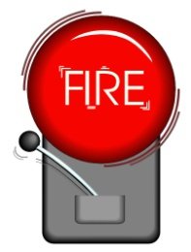

14. Where do you go when the fire alarm rings during biology class?

